Radiometric analysis concerns

Assuming the source is **isotropic**, the incident power per pixel has the following shape:

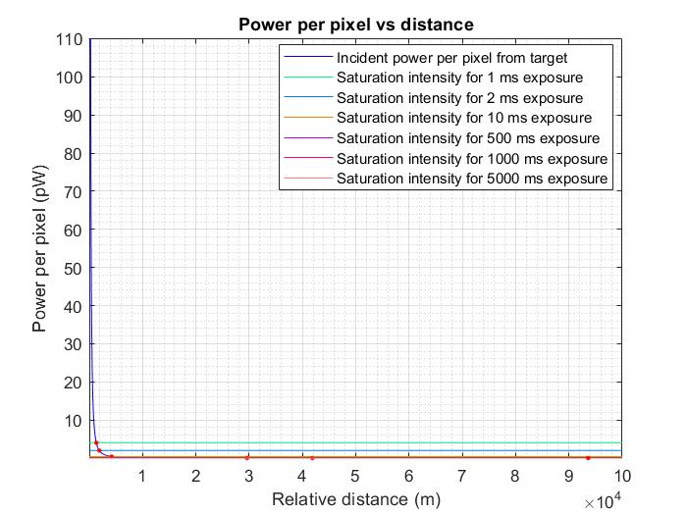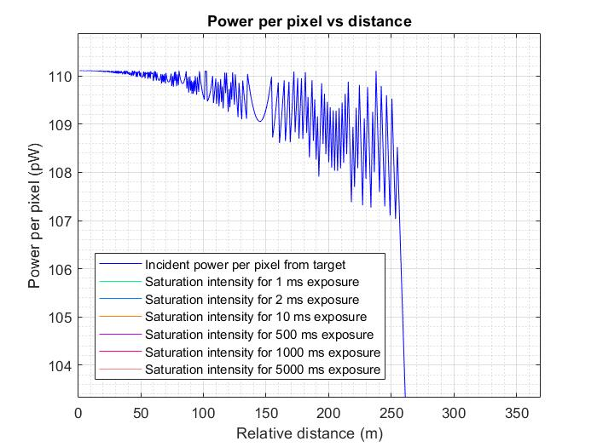

*Fig. 1 Power per pixel versus distance Fig. 2 Detail of the same plot*

I believe it makes sense intuitively that the power raises as the target gets closer (inverse square law) and it starts leveling out in discrete steps as the power starts spreading over more and more pixels, reaching a specific value.

However, the power per pixel seems to high. In the following detail, you can see that at a 1 ms exposure the sensor is already saturating from 1300+ m; at a 2 ms exposure it saturates at almost 1900 m. At those distances, the target is barely covering a single pixel. Therefore, the incident power should be lower.

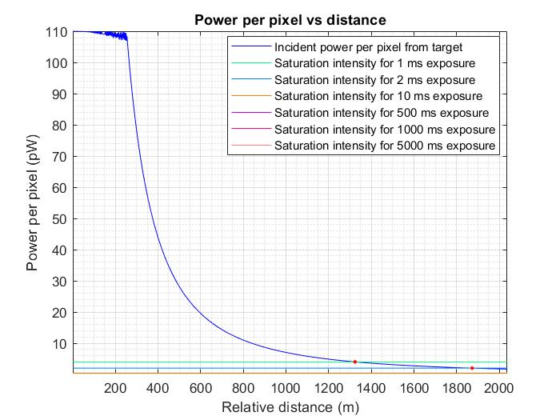

*Fig. 3 Detail No 2 of the isotropic source plot*

When using the view factor equation (taken from a book Akshay sent me—see below), the plot looks like this in short distances:

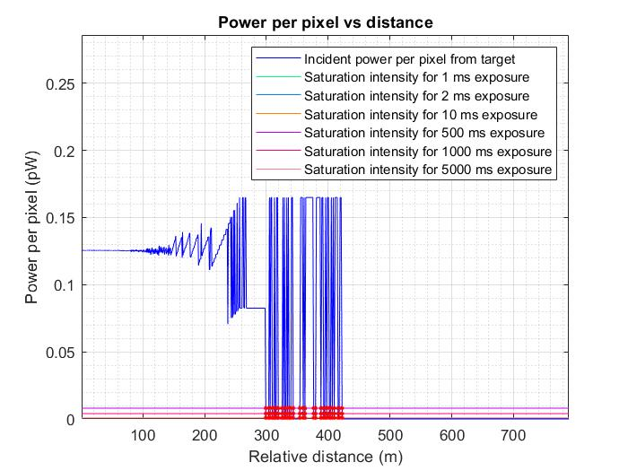

*Fig. 4 Detail of the power per pixel vs distance plot using the view factor equation*

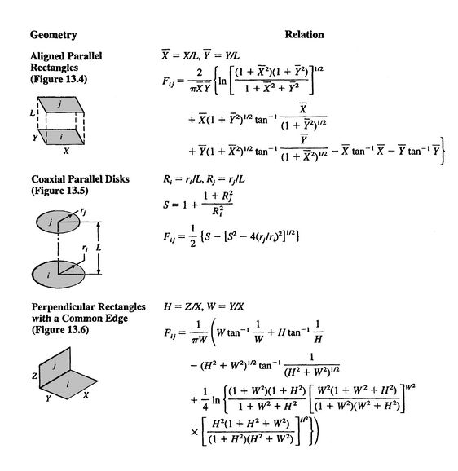

*Fig. 5 View factor equations for two coaxial parallel disks. Disk ‘i' is the radiating surface and ‘j’ the receiving one. These view factor equations were chosen due to their simplicity rather than how close they are to reality.*

As you can see in Fig. 4, the power per pixel is small enough for the shorter exposures to never saturate but when it comes to the 0.5 s, 1 s and 5 s exposures the results cannot be right. The power should not just disappear in intervals; it should ramp up a little more continuously. If we were to use this, then the target would be detected at a little farther than 400 m, then immediately saturate the sensor and so on and so forth.